**Project Title:** Market Basket Analysis

**Problem Statement:**

Unveiling Customer Behaviour through Association Analysis: Utilize market basket analysis on the provided dataset to uncover hidden patterns and associations between products, aiming to understand customer purchasing behaviour and identify potential cross-selling opportunities for the retail business.

**Abstract:**

This paper aims to present an approach to detect interrelations among product categories,which are then used to produce a partition of a retailer’s business into subsets of categories. The methodology also yields a segmentation of shopping trips based on the composition of each shopping basket.

**Objective:**

* To understand what Market Basket Insights is and how it is used.
* How does Market Basket insights work?
* Algorithm to implement Market Basket insights in python.
* Benefits of market basket insights.

**Market Basket insights:**

Market basket insights is a data mining technique used by retailers to increase sales by better understanding customer purchasing patterns. It involves analyzing large data sets, such as purchase history, to reveal product groupings, as well as products that are likely to be purchased together.

By recognizing these patterns of co-occurrence, retailers can make informed decisions to optimize inventory management, devise effective marketing strategies, employ cross-selling tactics, and even refine store layout for improved customer engagement.

**Working of market Basket insights:**

* identifying frequent item sets and generating association rules that express the likelihood of one item being purchased with the purchase of another item.
* It focuses on the order in which items are purchased in a transaction. It identifies frequent item sequences and generates sequential association rules
* It involves grouping similar items or transactions into clusters or segments based on their attributes. It

For example, if customers are buying milk, how probably are they to also buy bread (and which kind of bread) on the same trip to the supermarket? This information may lead to an increase in sales by helping retailers to do selective marketing based on predictions, cross-selling, and planning their ledge space for optimal product placement.

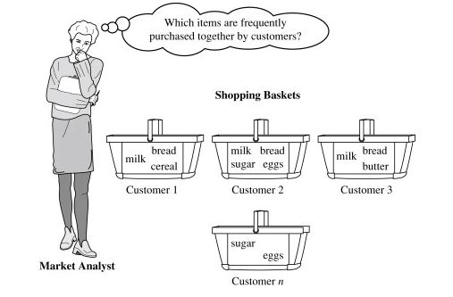

**Algorithm to implement market basket insights:**

To implement market basket insights by using python with Apriori algorithm, to find frequently co-occurring products and generate insights for business optimization.

* Apriori Algorithm is a widely-used and well-known Association Rule algorithm used in market basket insights.
* It is also considered accurate and overtop AIS and SETM algorithms.
* It helps to find frequent itemsets in transactions and identifies association rules between these items.
* It uses the concepts of Confidence and Support.

We can implement this Apriori algorithm by using python

**Benefits of market basket insights:**

* **Retail:** identify frequently purchased product combinations and create promotions or cross-selling strategies.
* **E-commerce:** suggest complementary products to customers and improve the customer experience.
* **Hospitality:** identify which menu items are often ordered together and create meal packages or menu recommendations.
* **Healthcare:** understand which medications are often prescribed together and identify patterns in patient behavior or treatment outcomes.
* **Banking & finance:** identify which products or services are frequently used together by customers and create targeted marketing campaigns or bundle deals**.**
* **Telecommunications:** understand which products or services are often purchased together and create bundled service packages that increase revenue and improve the customer experience